A MINI- PROJECT REPORT ON

***“SMART WEATHER*** ***MONITORING SYSTEM ”***

SUBMITTED BY

**Aarya Shelar 19IT1057**

**Samruddhi Patil 17IT2011**

Supervisor

**Mrs. Deepali Patil.**



Department of Information Technology

Dr. D. Y. Patil Group’s

**Ramrao Adik Institute of Technology**

Nerul, Navi Mumbai

(Affiliated to University of Mumbai**)**

( 2020)

# **CERTIFICATE**

This is to certify that the project entitled **` SMART WEATHER MONITORING SYSTEM** ‘ being submitted by **AARYA SHELAR 19IT1057, SAMRUDDHI PATIL 17IT2011** to the University of Mumbai in partial fulfillment of the requirement for the award of the degree of **‘B. E. I. T’** in **“IOE (Mini Project) Lab”**.

**Project Guide External Examiner Head of Department**

(Mrs.Deepali Patil) ( ) (Dr. Ashish Jadhav)

# **DECLARATION**

We declare that this written submission represents our ideas in our own words and where others' ideas or words have been included, we have adequately cited and referenced the original sources. We also declare that we have adhered to all principles of academic honesty and integrity and have not misrepresented or fabricated or falsified any idea/data/fact/source in our submission. We understand that any violation of the above will be cause for disciplinary action by the Institute and can also evoke penal action from the sources which have thus not been properly cited or from whom proper permission has not been taken when needed.

**Name and Roll No. of Students Signature**

1. AARYA SHELAR (19IT1057) ( )
2. SAMRUDDHI PATIL (17IT2011) ( )

Date:

Place:

# **ACKNOWLEDGEMENT**

The project “SMART WEATHER MONITORING” is creative work of many minds. A proper synchronization between individual is must for any project to be completed successfully. One cannot imagine the power of the force that guides us all and neither can we succeed without acknowledging it.

We would like to express our gratitude to Principal **Dr. Mukesh D. Patil** and **Dr. Ashish Jadhav,** our Head of the department, Information Technology Engineering for encouraging and inspiring us to carry out the project in the department lab.

We would also like to thank our Guide **Mrs. Deepali Patil**, Department of the Information Technology Engineering for her expert guidance, encouragement and valuable suggestions at every step.

We also would like to thank all the staff members of the Department of Information Technology Engineering for providing us with the required facilities and support towards the completion of the project.

Last but not the least we are thankful to our parents and friends for their constant Inspiration, encouragement and well wishes by which we have made a challenging project.

AARYA SHELAR 19IT1057

SAMRUDDHI PATIL 17IT2011

# **PREFACE**

We take great opportunity to present this Mini Project report on “**SMART WEATHER MONITORING SYSTEM”** and put before readers some useful information regarding our project.

We have made sincere attempts and taken every care to present this matter in precise and compact form, the language being as simple as possible. We are sure that the information contained in this volume certainly prove useful for better insight in the scope and dimension of this project in it true perspective.

The task of the completion of the project though being difficult was made quite simple, interesting and successful due to deep involvement and complete dedication of our group members.

**TABLE OF CONTENTS**

**Declaration …………….…….………………………………………… I**

**Acknowledgement ……...……………………………………………… II**

**Preface …………….…………………………………………………… III**

**Table of Contents ……………………………………………………… IV**

**Table of figures ...…………………………………………………….… V**

**Abstract…….....…………………………………………………..…….. VI**

**TABLE OF CONTENTS**

**Sr. No. Topic Page No.**

1. **INTRODUCTION………………………………………………………………..8**
   1. **IOE INTRODUCTION, CHARACTERISTICS ………………………….8**
   2. **PROBLEM STATEMENT………………………………………………….10**
   3. **OBJECTIVES………………………………………………………………..11**
2. **LITERATURE SURVEY……………………………………………………….12**
   1. **MOTIVATION………………………………………………………………14**
3. **PROPOSED SYSTEM…………………………………………………………..15**
   1. **INTRODUCTION OF PROPOSED SYSTEM AND**

**ARCHITECTURE …………………………………………………………...16**

* 1. **HARDWARE AND SOFTWARE REQUIREMENTS……………………17**

1. **IMPLEMENTATION……………………………………………………………18**
   1. **CIRCUIT DIAGRAM USING SIMULATOR……………………………...18**
   2. **CONNECTION DETAILS…………………………………………………...19**
   3. **CODE………………………………………………………………………….20**
2. **RESULT…………………………………………………………………………...46**
   * 1. **Data Analysis ……………………………………………………………..46**
     2. **Snapshots of your web application………………………………………47**
3. **CONCLUSION AND FUTURE SCOPE………………………………………..53**
   1. **CONCLUSION……………………………………………………………….53**
   2. **FUTURE SCOPE…………………………………………………………….53**
4. **REFERENCES……………………………………………………………………54**

## 1.INTRODUCTION

* **What is IOE?**

IoE is based on the idea that in the future, internet connections will not be restricted to laptop or desktop computers and a handful of tablets, as in previous decades. Instead, machines will generally become smarter by having more access to data and expanded networking opportunities.

Actual IoE applications range from digital sensor tools/interfaces used for remote appliances to smarter and more well-connected mobile devices, industrial machine learning systems and other types of distributed hardware that have recently become more intelligent and automated.

**CHARACTERISTICS**

### 1. Connectivity

### Connectivity is an important pillar of the IoT infrastructure. IoT devices should be connected regardless of their presence. Without connection, nothing makes sense.

### 2. Identity

### Each IoT device has its unique identity. If it needs to access the data from specific device then its identification element is very helpful.

### 3. Intelligence

### The extraction of data from the sensor devices is very important. This data is only useful if it is interpreted properly. IoT perform operations on sensed data in such a way that the results are useful for us. It is the intelligence property of IoT.

### 4. Scalability

### The number of IoT devices are increasing day by day. Hence, the scalability of an IoT should be enough that it can handle the massive traffic.

### 

### 

### 

### 5. Dynamic and Self-Adapting

### IoT devices should dynamically adapt themselves according to situations. For example a camera can capture data according to light conditions. It is shifted to night or day mode automatically. It is self-Adapting technique

### 6. Architecture

### IoT architecture should be hybrid, supporting different manufacturers. So, it cannot be homogeneous in nature. IoT is not the name of any engineering branch. IoT comes to picture when multiple domains come together.

### 7. Safety

### Safety should be the top priority. But in case of IoT, Safety is big challenge because multiple things are connected through internet. And security at each node is a critical and tough task.

**1.2 PROBLEM STATEMENT**

In today’s fast-moving world, rapid detection of weather and related components is the need of the hour. An IoT network with sensors will facilitate such rapid updating and analysis of weather and allow the user to understand weather around them. This network will also open up domains like data analysis for weather and even prediction for the near future using data patterns.

**1.3 OBJECTIVES**

* This system uses Arduino, ESP8266, DHT11, LDR etc. for data collection from the environment. These sensors are compactly organized to make the project modular and portable.
* The system utilizes ThingSpeak API to send data to the cloud from which it may be used for data analysis, weather prediction, fast monitoring and other REST applications.
* This will greatly reduce reliance on inaccurate city level predictions and give pinpoint accurate results to the area

**2.LITERATURE SURVEY**

# Internet of Things (IoT) and cloud computing plays a vital role in today’s Tele-monitoring health system. This system keeps track of an area’s weather with DHT11, LDR using Arduino Uno board. The weather data is collected and displayed on a ThingSpeak where user can access and communicate with each other without physical presence. Using cloud computing, the data can be stored, updated and accessed from anywhere in the world. It is very suitable for rural areas where weather reporting facilities are inaccurate or are not available.

# This system performs basic sensing of weather parameters regularly and reports the data to the cloud. The result data are then displayed as Tables in ThingSpeak from where it can be exported and used according to the user’s needs.

# IoT along with smart devices reduce complexity and complications in the weather system. The penetration of mobile technologies and smart devices over the weather system causes a huge impact on the world. The full-fledged utilization of these applications in today’s world is made aware to the people for improving and maintaining the good quality of environment. Apart from regular monitoring of weather through the system, the main objective is to drastically reduce monitoring times and cut down expensive or inaccurate expenses on weather apps.

# IoT based system with the help of smart devices and objects improves the healthcare monitoring system effectively, thus by reducing the inefficiencies of existing systems. Smart devices with new and upgraded technologies enhance the data accuracy to be collected, real-time accessibility of weather, intelligent integration of data collected, maintaining the integrated data smartly through cloud service, etc.

# Despite monitoring, there are quite a few challenges in using these devices for a long time. Firstly, the device has small size, rough use and low energy consumption. Secondly, the major challenge is of the accuracy, validity and integrity of measurement data with other devices.

# The use of Internet of Things (IoT) and its applications in the weather tracking industry leads to seamless flow of information between devices and cloud, thus making tracking cost effective and improving the quality of prediction.

**2.1 MOTIVATION**

* In rural areas, the facilities for tracking of weather are limited. The poor quality of enables issues in tracking system. Everyone should get the knowledge of weather as easy and early as possible.
* In developing countries there is lack of resources and management to reach out the problems of individuals. A common man cannot afford the expensive and complex systems for tracking. For this purpose various systems which give easy and assured caring unit has been developed. Theses system reduces time with safely handled equipment.

**3.PROPOSED SYSTEM**

### 3.1 INTRODUCTION OF PROPOSED SYSTEM AND ARCHITECTURE

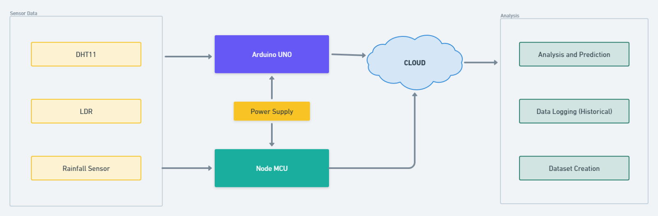

Fig 1: Arduino Uno communication with sensors and Thingspeak

### 

### 3.2 HARDWARE AND SOFTWARE REQUIREMENTS

HARDWARE REQUIREMENTS :

1. Arduino UNO
2. ESP8266 Wi-Fi Module
3. Temperature Sensor
4. Humidity Sensor
5. Resistors
6. NodeMCU
7. LED

### SOFTWARE REQUIREMENTS:

1. Arduino IDE
2. Thingspeak Website

**COMPONENT DESCRIPTION**

1. Arduino UNO

Arduino is an open source computer hardware and software company, project, and user community that designs and manufactures single-board microcontrollers and microcontroller kits for building digital devices and interactive objects that can sense and control objects in the physical world.

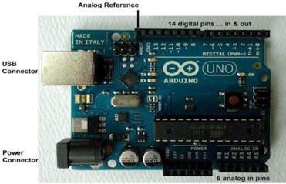

1. ESP8266 Wi-Fi Module

The chip was popularized in the English-speaking maker community in August 2014 via the **ESP-01** module, made by a third-party manufacturer Ai-Thinker. This small module allows microcontrollers to connect to a Wi-Fi network and make simple TCP/IP connections using Hayes-style commands. However, at first, there was almost no English-language documentation on the chip and the commands it accepted. The very low price and the fact that there were very few external components on the module.

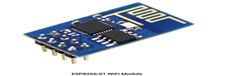

1. NodeMCU

**NodeMCU** is a low-cost open source IoT platform. It initially included firmware which runs on the ESP8266 Wi-**Fi** SoC from Espressif Systems, and hardware which was based on the ESP-12 module. Later, support for the ESP32 32-bit MCU was added.

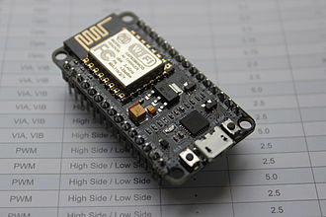

1. DHT11

The DHT11 is a commonly used Temperature and humidity sensor that comes with a dedicated NTC to measure temperature and an 8-bit microcontroller to output the values of temperature and humidity as serial data.

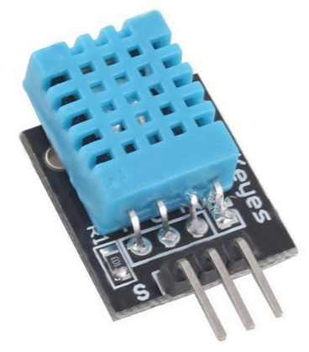

**4.IMPLEMENTATION**

**4.1 CIRCUIT DIAGRAM USING SIMULATOR**

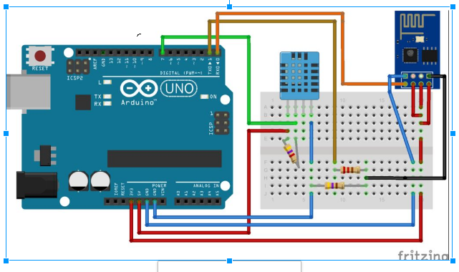

Fig 2: Connection of Arduino Uno, LCD Display and ESP8266 Wi-fi Module

### 4.2 CONNECTION DETAILS

**Connection of Arduino with Pulse Sensor and Temperature Sensor**

1. Connect Pulse Sensor output pin to A0 of Arduino and other two pins to VCC & GND.
2. Connect DHT11 Temperature Sensor output pin to 3 of Arduino and other two pins to VCC & GND.
3. Connect the LED to Digital Pin 7 of Arduino via a 220-ohm resistor.
4. Connect Pin 1,3,5,16 of ESP8266 to GND.
5. Connect Pin 2,15 of DHT11 to VCC.
6. Connect Pin 4,6,11,12,13,14 of LCD to Digital Pin 12,11,5,4,3,2 of Arduino.
7. The RX pin of ESP8266 works on 3.3V and it will not communicate with the Arduino when we connect it directly to the Arduino. So, we will have to make a voltage divider for it which will convert the 5V into 3.3V. This can be done by connecting the 2.2K & 1K resistor. Thus the RX pin of the ESP8266 is connected to pin 10 of Arduino through the resistors.
8. Connect the TX pin of the ESP8266 to pin 9 of the Arduino.

**5.RESULT**

**5.1DATA ANALYSIS**

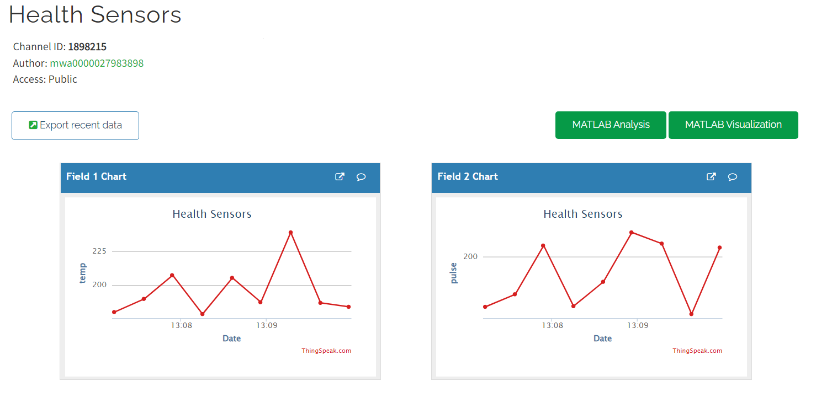

Fig 4: Viszualization of Weather data

**5.1.2 SNAPSHOTS**

**Authenticated Access to Patient Vitals via NodeMCU**

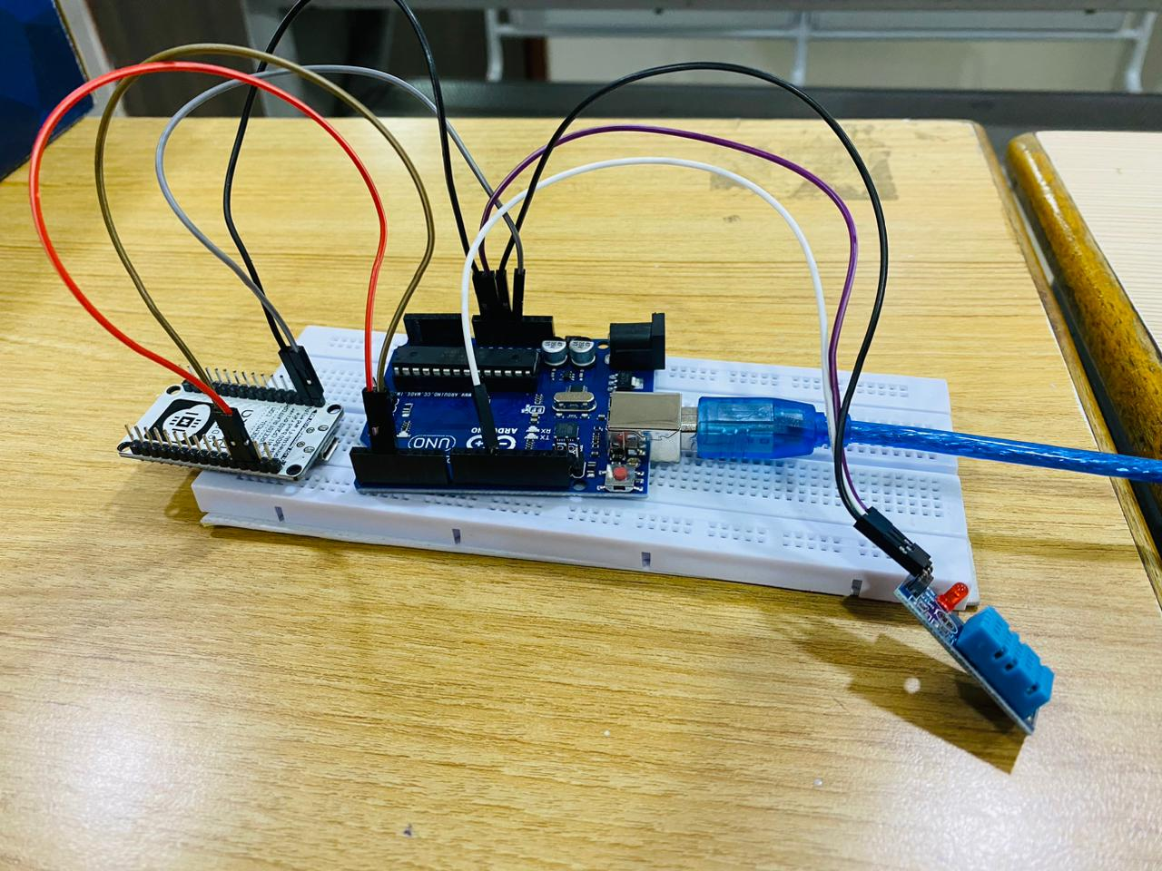

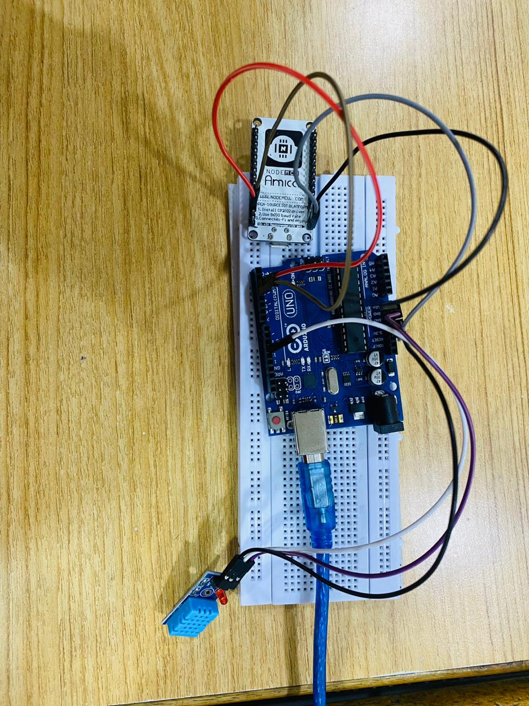

**6.CONCLUSION**

Thus, the proposed system could gather, reading of various important indications of the patient and after that evaluate at cloud then caution the doctor or concerned individuals about the health condition. It monitors the vital signs and sense abnormalities. These abnormalities alert the medical staff, it reduces the manual monitoring. The system uses Thingspeak to send the data to the cloud platform. This protocol transmits the readings of important patient’s vital sense and helps to give a pictorial representation of information. This system is cost effective and user friendly and thus its usage is not restricted or limited to any class of users. It is a very efficient system and very easy to handle and thus provides great flexibility and serves as a great improvement over other conventional monitoring systems.

**6.1 FUTURE SCOPE**

The device can be augmented with various other sensors to complete the suite of sensors in the weather monitoring system. Data analysis can be internalized and processed data can be sent instead of raw data to reduce data transmission costs and other storage systems. The

# **7.REFERENCES**

[1] “Akhila, V., Vasavi, Y., Nissie, K. and Rao, P.V., 2017. An IoT based system using Arduino Uno. International Journal of Research in Information Technology, 1(1), pp.1-9.”

[2] “Integrating WSN with Web Services for Weather Record Management using ESP8266”,” Advance Computing Conference (IACC), 2013 IEEE 3rd International”

[3] “Vandana Milind Rohokale, Neeli Rashmi Prasad, Ramjee Prasad, “A Cooperative Internet of Things (IoT) for Weather Monitoring and Control”,978-1-4577-0787-2/11/ ©2011 IEEE”

[5] “http://www.ahmad.rahmati.com/papers/07.DSN.DHT11_reliability.pdf”

[6] “S.M. Riazulislam, Daehankwak, M.H.K.M.H., Kwak, K.S.: The Internet of Things for Weather: A Comprehensive Survey. In: IEEE Access (2015).”